DAta Compendium

BHRC AND ITS COUNTIES

Expanded March 2022

*This document was created by the data team at Buckeye Hills Regional Council to assist with their planning efforts. All tables should be sourced and dated.*

## TABLE OF CONTENTS

INTRODUCTION 1

POPULATION INFORMATION 2

ECONOMIC INFORMATION 6

EDUCATION 16

PERSONAL HINDRANCES 17

CHANGELOG 20

# INTRODUCTION

Buckeye Hills Regional Council, in their planning efforts, is often tasked with compiling a wide variety of statistical information from a number of sources. To streamline that effort, the most-often requested data is compiled here. This data will be updated as often as possible. Each table should be marked with a source, a date range for the data, and information on when that data was accessed. The tables (included source information and data explainers) are combined as an image so they can be easily added to reports as needed.

This is a living document. Expect the specific statistics, the organization, and anything else to change over time. For questions about the statistics contained here, please contact a GIS Specialist at Buckeye Hills.

BHRC values are often calculated by either summing or averaging the values of its constituent counties, whichever is most appropriate. This does have the possibility of hiding or magnifying estimation errors in the county data. It has been deemed that this is the best option for calculating values for the Buckeye Hills region though, as there are no numbers estimated at this geography directly available from state and federal agencies specializing in these statistics.

# POPULATION INFORMATION

Every ten years the federal government is constitutionally required to perform a census, counting everyone residing within the United States. For many places, this comprehensive count happens too infrequently, so the US Census Bureau has developed a few tools to provide deeper data, more frequent data, or sometimes both. For incorporated places (cities and villages) and larger, the Census Bureau calculates annual population estimates. These yearly estimates are updated every year and provide a more granular look at population shifts between the decennial census. Dramatic shifts can happen to communities in a ten-year period, and these estimates can help capture those shifts. The two most-recent full census counts are included for additional context.

The Ohio Development Services Agency projects population estimates for the state and every county out to the year 2040. These numbers give an idea of what the state expects the county populations to be in the given years, and can help communities plan accordingly. They are updated annually and can be checked against the Census Bureau estimations to track their accuracy.

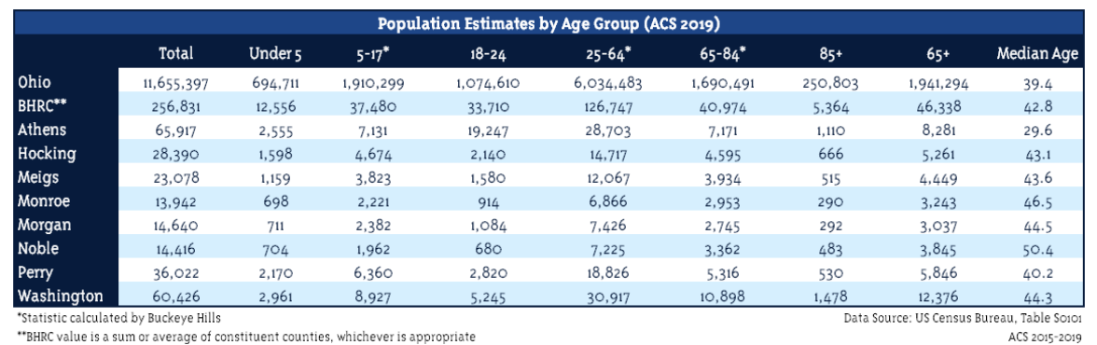

Age groups require different services to meet their need. Children under 5 are unlikely to be in school and need to be cared for while their parents work. The population 65 years and older are likely to be retired and have different needs from their built environment. Those 85 and older even more so. The ages 25-64 are the prime working years. We would expect a significant percentage of these people to be part of the labor force, and we cannot expect the labor force to be much larger than that.



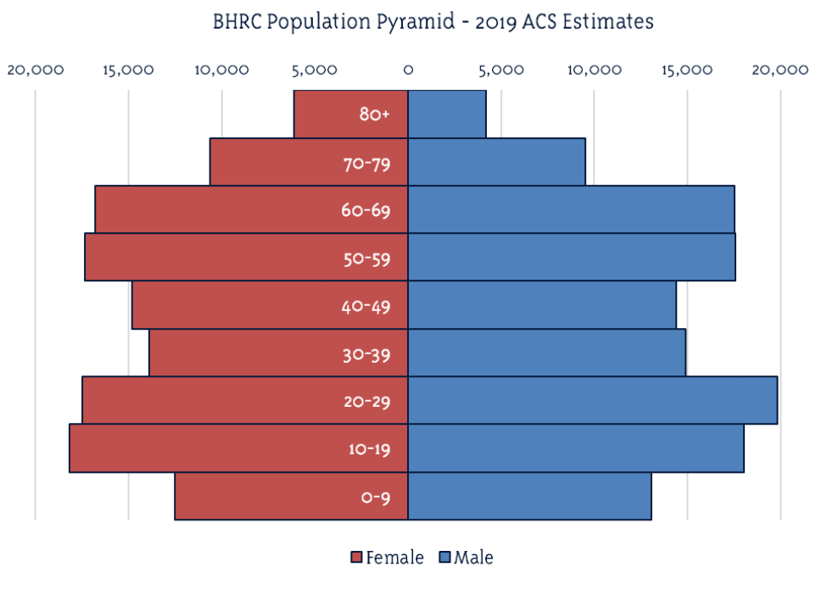Population pyramids use population data to show the distribution of age groups by sex. They help with demonstrating the dominant age groups within a given population. A bottom-heavy pyramid would indicate a very young population while a top-heavy pyramid would indicate an aged population. Assuming populations don’t change significantly, the pyramid can also give users and idea of what future population distributions will look like as people progress up the pyramid in age.

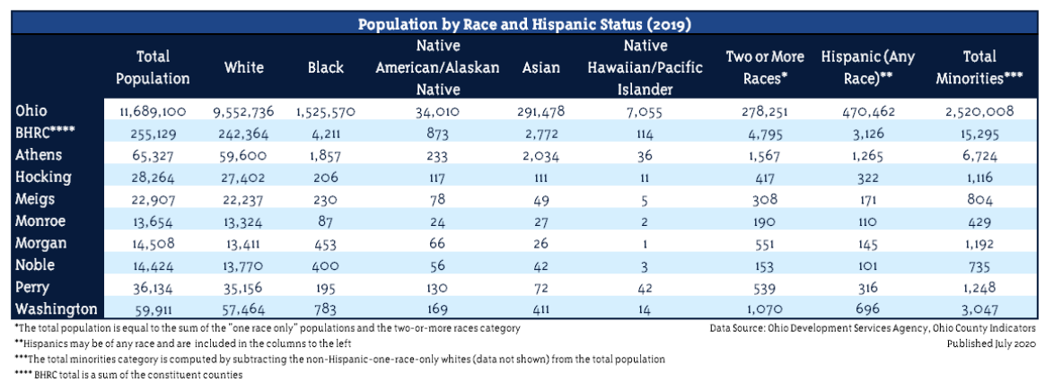

Distribution of race and ethnicity (specifically Hispanic status) is important for a number of activities in the Buckeye Hills region. We ensure that the activities we engage in are not adversely or primarily affecting a specific population, and minority populations are one category of people we are specifically required to consider, as part of the identified environmental justice populations.





Residence status provides information on the independence of the region’s elderly population. Those in group quarters tend to be the least independent, and those living alone may require assistance to maintain their independence. Those in households not alone, however, likely already have someone to rely on to maintain their general independence.

# ECONOMIC INFORMATION

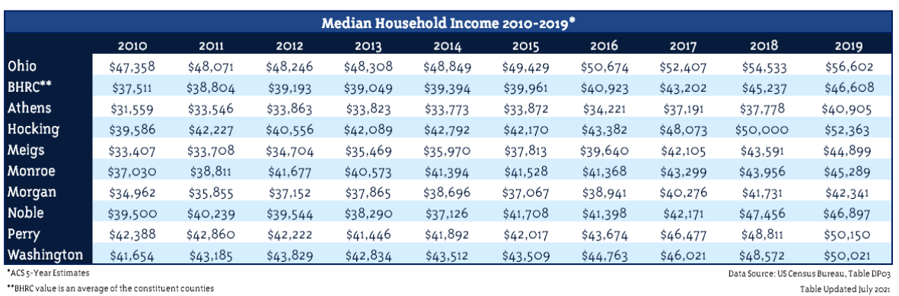Unemployment rates are a prominent indicator of the economic health of an area. It is important to note that unemployment rates are not compared against the total population, but against the civilian labor force, or the number of people employed/looking for work. This number does not tell you how many people in the county are not working, but how many people who want work cannot find it. While the Appalachian region often has a higher rate than the state or US at-large, this can partially be accounted for with the relatively small populations in Appalachian counties. Much smaller raw numbers of unemployed folks can make for a higher percentage of the county’s labor force. The region’s high numbers of elderly also contribute to this, as many of them have dropped out of the labor force, thus making it easier for relatively small numbers of people to make up high percentages of the labor force.

Median household income is an oft-used metric for the quality of life for a region. Comparing these post-tax values can give you some idea about how the people in those areas are living. Household income covers all people living in a single housing unit, and includes single people. This is where it differs from family income, which includes only households that have 2 or more people related by birth, marriage, or adoption. This value can also be compared to the median home sales price to determine the health of the housing market. Typically, it is accepted that housing prices should be around three times the household income.

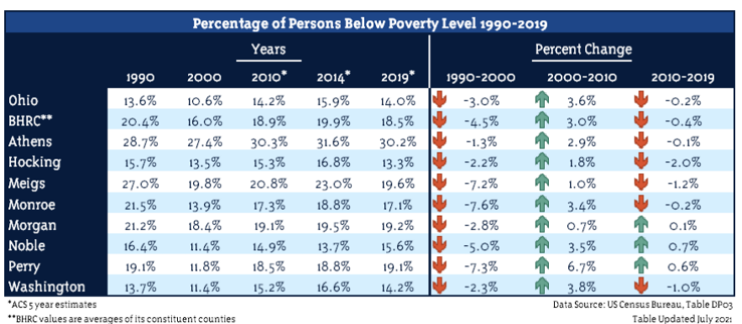

The Census Bureau defines poverty status as a family’s combined income compared to a threshold, updated yearly, and based on the family’s size. It does not include people in institutional group quarters (such as prisons and nursing homes), people in college dormitories, people in military barracks, and people living in situations without conventional housing (and who are not in shelters). Additionally, poverty status cannot be determined for unrelated individuals under age 15 (such as foster children) because income questions are asked of people age 15 and older and if someone is under age 15 and not living with a family member, the Bureau does not know their income. These people are not included in the “poverty universe” that these percentages are calculated using. This value can be used to gain insight into the economic health of an area, as people in poverty may or may not be working, and thus are different than the unemployed population, and they may be hidden in the household income statistics. People in poverty are also an environmental justice population and must be considered in Buckeye Hills’ planning activities.

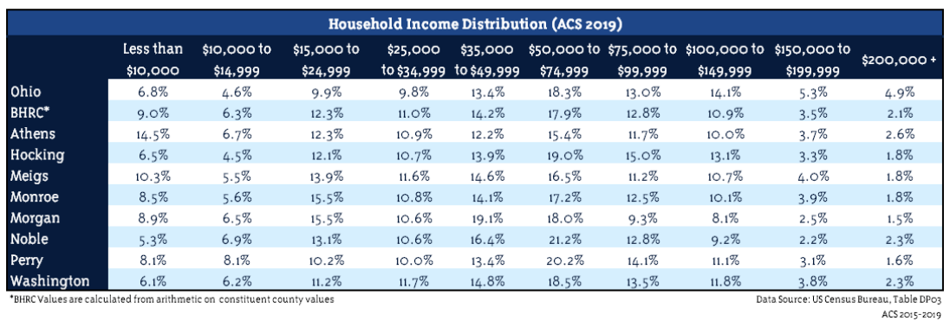

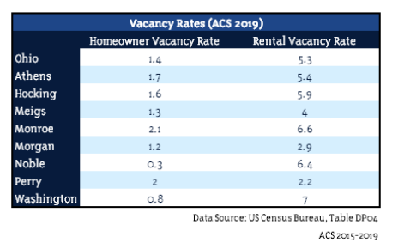The distribution of household income digs deeper into economic wellbeing of households in the region than the simple median household income. Here, it can be seen how the counties stack up to Ohio as a whole in the distribution of its households into the given income categories. At a minimum we would like these numbers to be similar between the state and region and the region and the counties.

Vacancy rates show what percentage of properties are available within a given area. A higher vacancy rate implies that more properties are available for rent or to own, while a lower vacancy rate implies that there are less properties available for rent or to own.

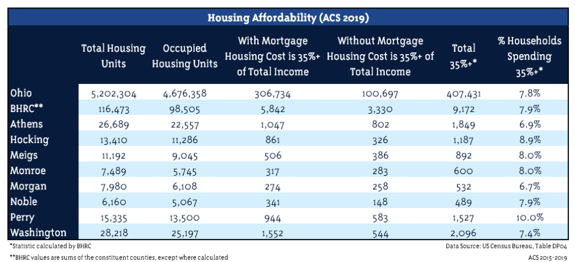

The more a household spends of their income on housing, the more precarious their economic situation is. A general good health metric is to keep this value below 35% of total income. The more households spending more than 35% of their income on housing, the more fragile the communities housing situation is.

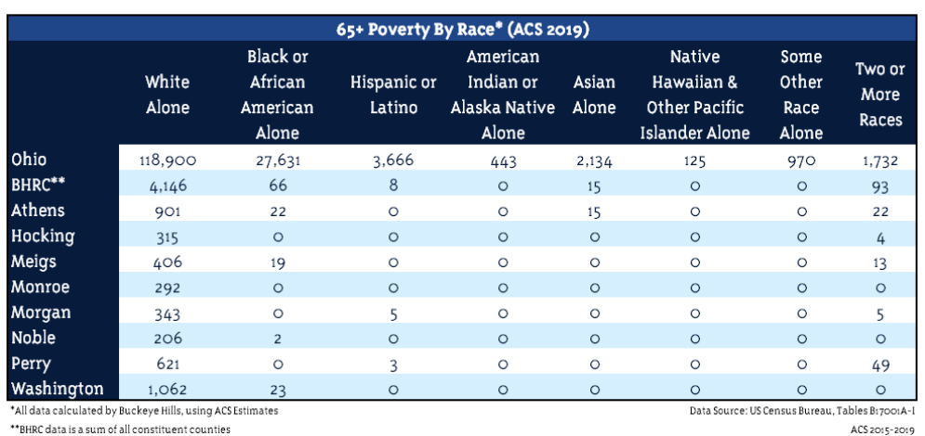

Housing an Area Agency on Aging means that Buckeye Hills must pay close attention to the aging population. Knowing the demographics of our elderly population, in particular here the racial makeup of those populations both over the age of 65 and in poverty, helps us understand the unique challenges our elderly citizens are facing.

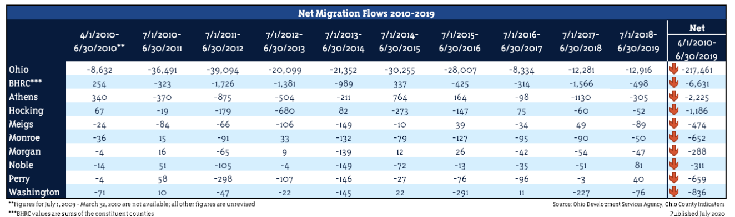

Net migration captures the total number people who have both moved in to and out of a community into one value. Tracking these numbers over time can help us understand whether counties are attracting or losing people and to what degree.

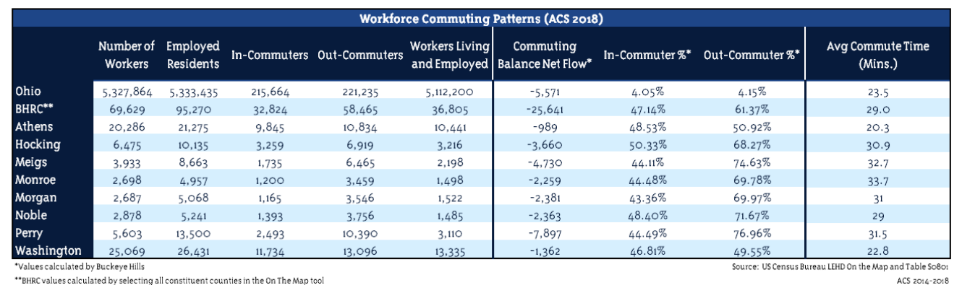

The commuting patterns of a region’s workforce offers insights into the job/housing opportunities within a region. A community with high number of out-commuters has a weaker job market, while a community with a high number of in-commuters may have a short housing supply. The closer the net flow is to “0” the more balanced a regions housing and employment opportunities.

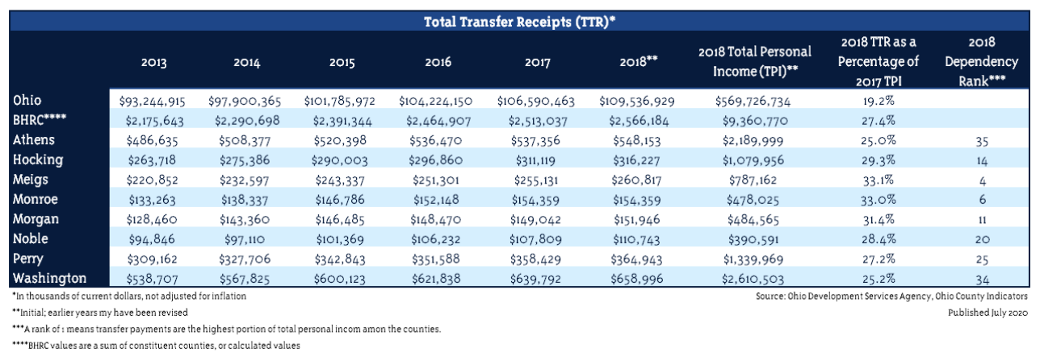

A transfer receipt is a payment to a person, usually in monetary form, for which that person has not rendered a service. Examples of transfer receipts include social security, Medicare, Medicaid, income maintenance such as supplemental security and nutrition assistance programs and the earned income tax credit, etc. Private sector transfer payments also exist and are counted here. Transfer receipts are another indicator of economic health. A robust local economy will see these transfer payments make up a smaller percentage of personal income.

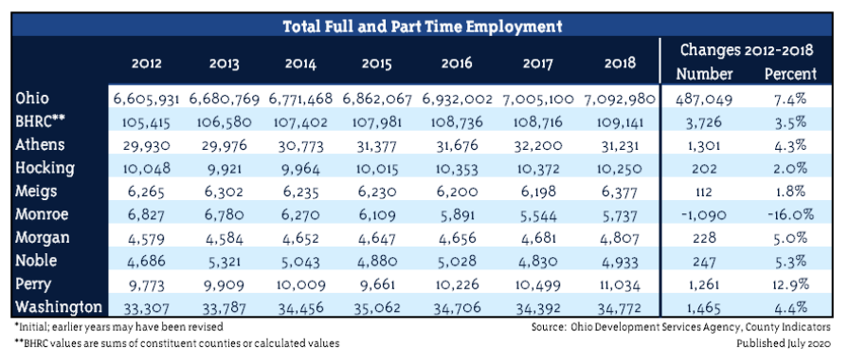

This table catalogs the total number of jobs, both full and part time, in a county. One person could hold multiple jobs and would be counted here multiple times. Seeing these numbers increase at a gentle, consistent pace is a healthy sign for a community’s economy. Obviously, a decline is not a good sign for a community, but a dramatic increase could also be a destabilizing force.

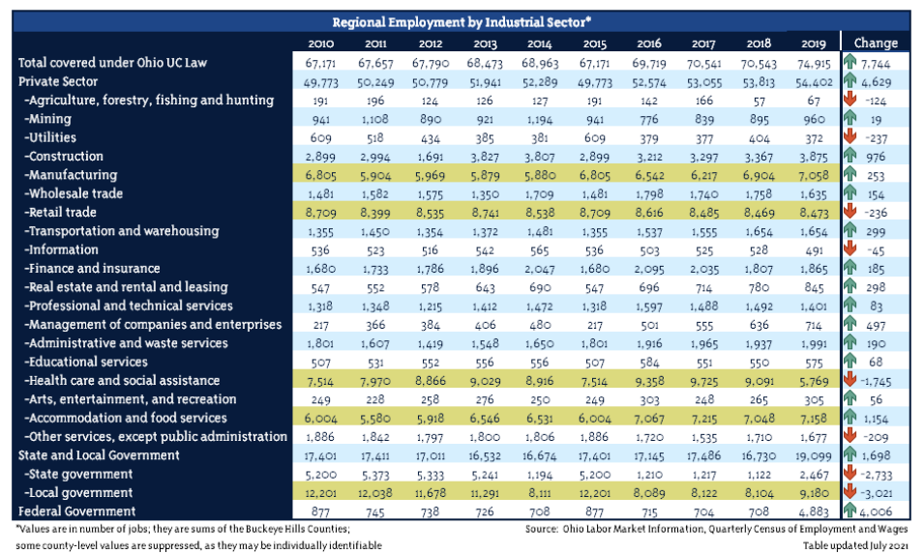

Ohio Labor Market Information tracks employment by industry for every county in Ohio. The top 5 sectors with the most employment have been highlighted in yellow for each year. Knowing what industries employ the most people in the region can help us determine where efforts should go to support existing businesses, or what industries could use additional attention. It must also be noted that fluctuations in the regional value could be tied to the suppression of county-level data, which is often suppressed for confidentiality purposes.

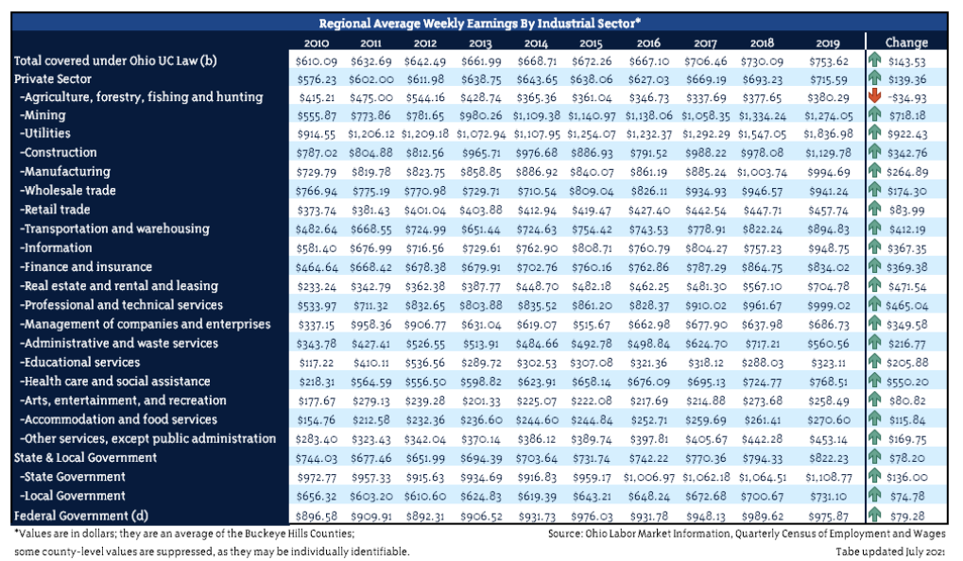

Based on inflation alone, weekly earnings should increase some for every industrial sector. In particularly hot sectors, weekly earnings may increase significantly. This could also be a sign of an industry contracting though, as only the highest paid members are left. It must also be noted that fluctuations in the regional value could be tied to the suppression of county-level data, which is often suppressed for confidentiality purposes.

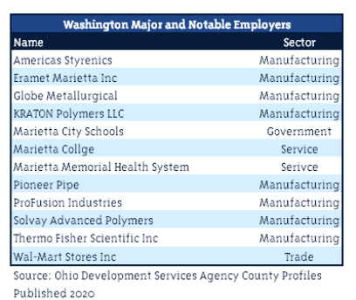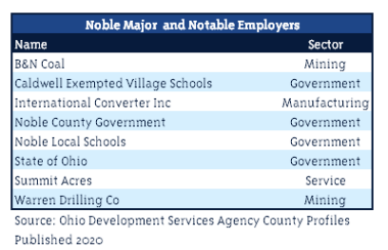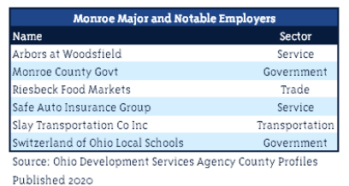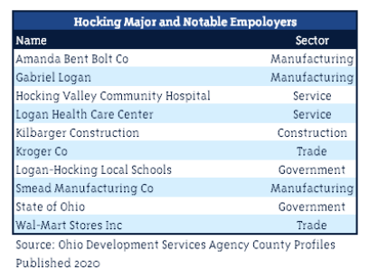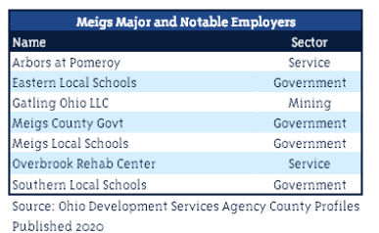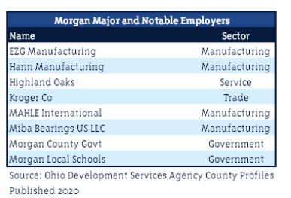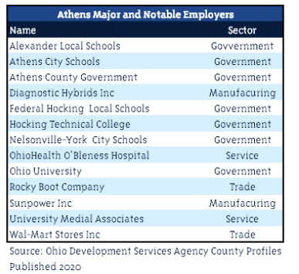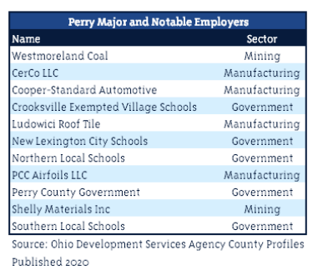

The notable employers in a county can show the diversity of the workforce, and they can reveal patterns within a region to show what types of industries employ the most people. Having similar employment sectors within a county can be a sign of low employment diversity, while having multiple different employment sectors can be a sign of a diverse workforce.

# EDUCATION

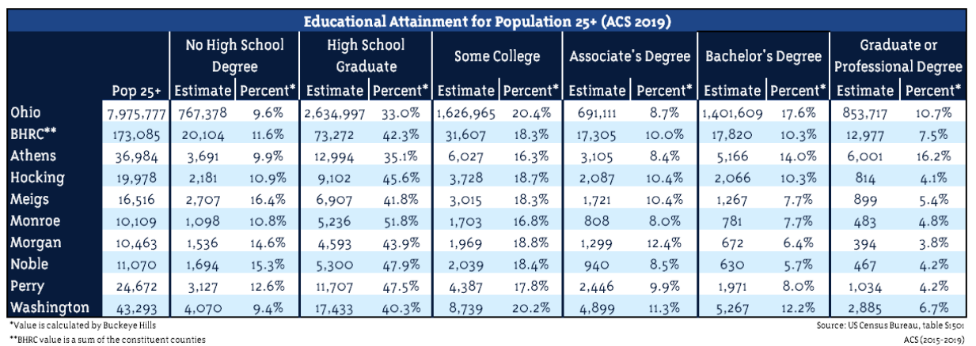

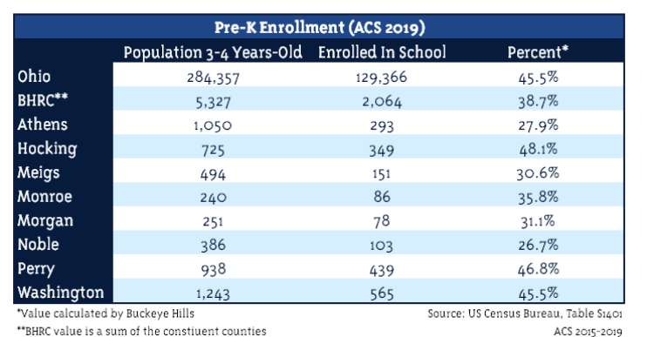Educational attainment metrics can give a few different insights into a community. First, there is significant correlation between educational attainment of a population and its average income. A more highly-educated population has a greater chance at achieving high incomes. Educational attainment has also been shown to correlate with health outcomes, with those reaching higher levels, on average, living longer than those that do not.

Evidence suggests that pre-school experience can prepare children for further success in life. It is also an economic indicator, as it can require a certain level of affluence to send young children to a pre-Kindergarten school.

# PERSONAL HINDRANCES

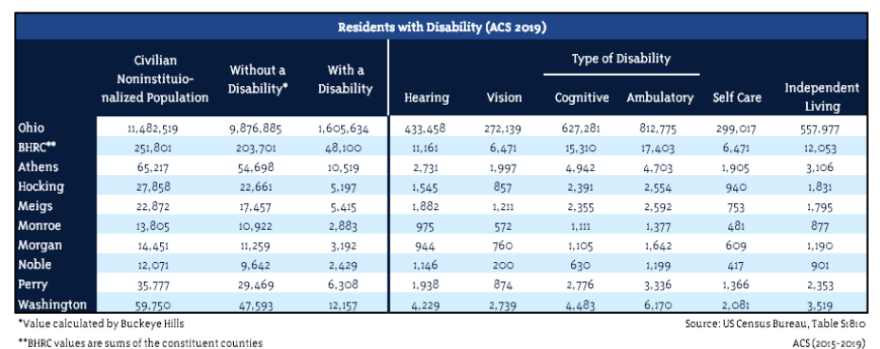

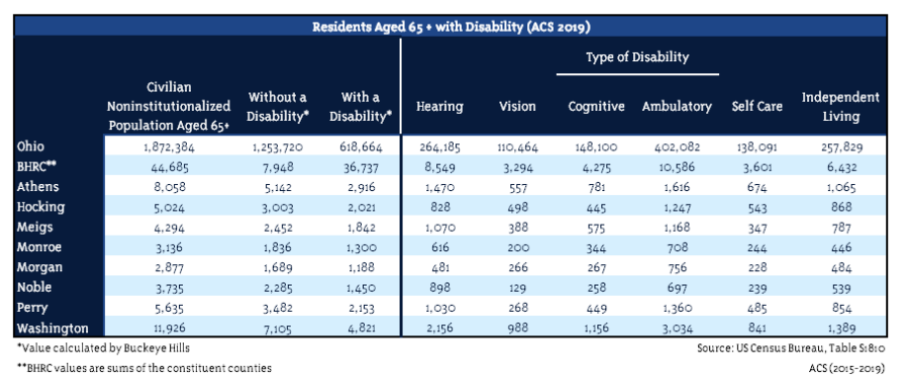



Disability status is important, particularly for senior populations, to ensure accessibility.

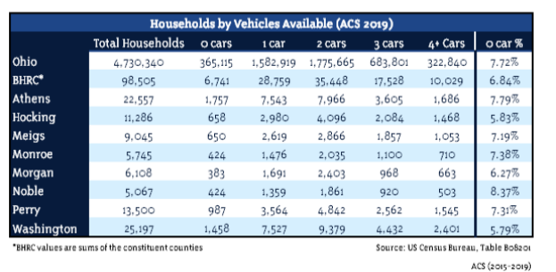

For some time now, participation in the public space, especially in rural areas, has required access to a personal vehicle. Understanding the number of households that do not have access to personal automotive transportation, and where those people are, can help Buckeye Hills and our partners identify and connect these population to available services, so they do not have to be or feel disconnected.



While the United States has no official language, English is the standard language of communication. An individual’s difficulty communicating in English could lead to difficulty elsewhere in life. Additionally, if significant cluster of people are identified with English-speaking difficulties, determining their first language should be determined, and attempts should be made to use that language in communication with them, if possible.

# CHANGELOG

**2022 March** – Service Area Tables added: Population Estimates by Groups Aged 65+, Estimated Majority and Minority Population by Groups Aged 65+, Population Aged 65+ by Residence Status, Population Aged 65+ by Ability to Speak English, Persons Aged 65+ for Whom Poverty Status Was Determined, and Disability Status by Age Group for Persons Aged 65+. Changelog was also added so changes could be tracked.

**2021 July** – Document is formally completed and published at <http://www.buckeyehills.org/data-center>